Community Technology...Guatemalan style…

by Paul Pitcher
There is no short description of my current job at Acción Cultural Guatemalteca (ACG), a small non-profit community and cultural development organization made up of entirely indigenous Mayan members who based in Santa Cruz del Quiché, Guatemala.
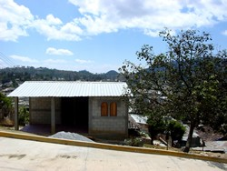
One-room, one-computer community technology center Santa Cruz del Quiche

ACG serves the indigenous Guatemalan population through projects like micro-credit, scholarships, improved stoves, HAM radios, training in traditional weaving, animal breeding and care (just to name a few) in 36 communities all over the countryside. Every time someone asks me what I do, it takes me at least 5 minutes and a few small stories to attempt to relate my variety of tasks. In many ways, it reminds of me of my work in community technology in Ohio at The Bridge, Oberlin’s Community Technology Center, where I joked with my boss that my job title was “Just doing anything that needed to be done.” And just in the same vein as my work in Ohio, one of my many assignments that was waiting for me when I walked into the office a little over a year ago was that of computer technician, computer teacher, and web designer. Though that may sound like a full time job, it is only a small part of the multifaceted yet simple globule that is my work in Guatemala.
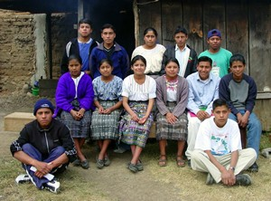
Students at the community technology center in Santa Cruz del Quiche

I spend many of my days on the road working with doctors, solar-powered HAM radios, leading delegations, translating from one language to another (both Spanish and K’iche’, the local Mayan language), meeting with villagers, etc. The key is the ability to provide the technology that ACG recognizes is necessary for all of its members to have the opportunity to learn in order to advance in the world and to be able to put the teaching of this “computer language” into a language that they could understand. It also requires me to, sometimes, go a little off the beaten path in order to provide these services.

I will tell you a story of a small community technology center out in the Guatemalan mountains, of doing what needs to be done to bring technology to those who have the desire to learn about it, and of bridging languages in order to bridge the digital divide:
As the northeast of the United States digs out from the crippling snow storms and we here in Guatemala can only watch this unbelievable phenomenon (my housemates still cannot grasp the concept of snow and its difference from ice) on the news in the sweltering heat wave that currently has gripped this country, I found myself in a very familiar place yet under what most would think are a little out of the ordinary circumstances. I couldn’t help but stumble upon a slight smile yesterday afternoon as I sat on a little microbus and sped back from a rural northern mountainous Guatemalan town. I spent 8 hours yesterday on buses for 22 minutes of work, 22 minutes of “community technology”.
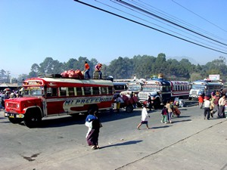
Chicken buses at the bus terminal in Xela

At around 8am yesterday morning I, along with two of my friends from a remote village above Uspantan, jumped on a second class Guatemalan chicken bus (named so by foreign visitors to Guatemala due to the boxes of baby chicks that normally travel in the storage space above the passengers heads or the full grown chickens sticking their heads out of the wicker bags in the aisle way next to you.) My friends Jacinto and Marcelino were headed home and I was off to install a printer at my one-room, one-computer “community technology center” in Uspantan that I set up last year for a group of 16 students who go to school in that town since their home village has no higher education facilities (higher meaning past 6th grade.) They had been in need of a printer for a while but due to limited financial resources and the scarce supply of parallel port printers in the small 5,000 person town of Uspantan they did not have many options. For their school work they often need to print up documents and it costs roughly Q1.50 ($0.15) for each page in black and white if they print at the one local computer room. I had sat down on a previous visit with them to discuss their needs and promised to return in a week or so with a printer for them. Since my town of Santa Cruz del Quiché is a little bigger (population 22,000) there are a few more options here for printers though I did not find a parallel port printer that would suit their needs. Due to the other fact that they needed to be able to buy injectable ink cartridges I decided on a Canon printer that would require the installation of a USB card. This meant that I would have to travel out to the community since none of the students could install this device.
The bus finally left at 9:20am (just a little late) and we sped on down the half-paved, half dust, sometimes one lane, snake shaped roadway out into the Guatemalan countryside climbing anywhere between 5000 and 9000 feet to reach our destination. We flew by farmers and their spades tirelessly working out under the scorching sun in their fields, past barefoot children playing soccer in the street who would scream and scramble to get out of the way as the bus came rattling around the hairpin turns, past women with long thin poles driving their sheep down the roadway from one field to another, just missing the scrawny dogs that appear with amazing frequency even where there are no villages and sometimes like to take naps in the middle of the road, through the dusty towns of adobe houses that materialize every few miles, through the mountains, in some of the most beautiful and poor country side imaginable. We arrived in Uspantan with about 10 minutes to spare, 10 minutes before the guardian of the key to the computer room went off to school. I, Jacinto, and Marcelino along with my multicolored sabana (Woven Guatemalan sheet used by women to carry babies and men to carry everything else from boxes, to clothes, to TV’s, etc.,) which was wrapped around the printer and my traveling bag which had a USB card and my tools stuffed inside, ran from the bus up the hill to the computer room and just caught my friend Francisco with the key before he went to school.
At this point, it was 12:55pm and the bus back to my home of Santa Cruz del Quiche left in 35 minutes. If I didn’t catch that one, I would have to wait till 4pm for the next bus, which would not get me home until 7:30 at night. So with incredible speed I disconnected all the cords, popped open the casing of the computer, quickly installed the USB card, reconnected all the cables including that to the new printer, installed the drivers for the card and printer, restarted the computer twice, and printed a test page off on the only paper available, a worksheet that I had along with me for my studies in the Mayan language of K’iche’. All this while jabbering along with the three Guatemalans watching me and explaining what I was doing and how to maintain the printer. I would not be able to make it back up to the town for at least a month and so they needed to be able to troubleshoot any problems that arose. When I finished, Marcelino proudly announced that I had finished in 22 minutes (he had been timing me). With that I shook hands with all the guys, said I wished I could stay longer and ran back down the hill to catch the microbus for another 3 hours back home.
And so, as I sat squished in the back of the sweltering metal-walled sweat-box microbus, heated by the blistering midday sun and surrounded by the other passengers packed into every space available like sardines, I found a refreshing smile on my face.
In looking at these adventures that are common place in my day to day life here in Guatemala I am conscious of many things. As the world becomes more and more wrapped within the technological turban, there are certain needs for countries, especially 3rd world countries, to keep up with this technology so that they do not fall farther and farther behind. In many ways, that means going beyond the normal calls of duty to translate the computer language into an assortment of methods, words, practical assignments, etc. It also means that the journeys to bring technology to the remote locations of the world, especially for those of us interested in “community technology” will be longer, harder, and more demanding but well worth it. What’s that old saying? “If there is a will, there’s a way”. Well, at least, here in Guatemala I have seen the will of the people to learn and to be a part of what computers bring to the world and so, sometimes, it’s up to me to figure out a way to give them the chance to participate.

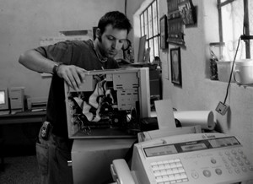
Paul “Pablo” Pitcher is currently a “Youth and Communications Worker” for Acción Cultural Guatemalteca in Santa Cruz del Quiché, Guatemala. He is a former “community technology” worker in Ohio and Boston who has translated many of those skills into his current work. He loves to travel, write stories, laugh, and find ways to bring technology to anyone who wants learn even if that means spending hours flying around dangerous curves in an old school bus.

